**Day 1**

* Redhat already provided complete private key -public key connected with student user.
* Don’t run ssh-keygen.
* You have to login using workstation.
* This system is only one who have GUI access.
* Add your playbook in home directory.
* Ansible software is preinstalled in controller node.
  + Else use sudo yum install ansible
  + Ansible --version to check ansible is installed or not.

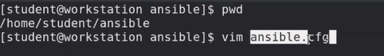

* + Create ansible config file in same folder (workspace).
* Copy global file directly and edit it.
  + Cp /etc /ansible/ansible.cfg ansible.cfg
  + You can now check using ansible --version.
* Always use config file of your workspace.

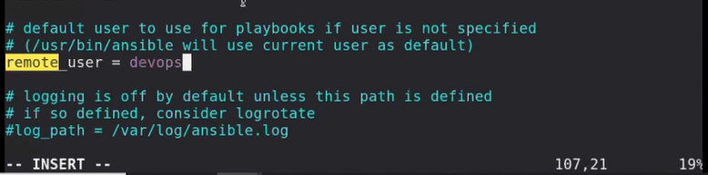

* Here you have to write user given in exam.
* Uncomment privilege escalation.
* Disable check_host_key.
* Roles is also created in same folder and mention this in config file for role path.
* Vim is not available but you can download it.
* Ssh keygen already setup so you don’t need to give password in inventory.
  + User is also set to root in config file.
* Always check each step working or not.
* Ansible all -a id
  + By default they use command module.
* When you use key to be checked you have to import a key.

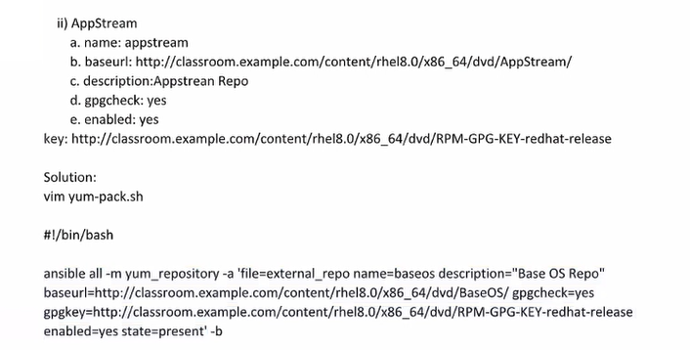

* + - B is for you want sudo power or not.
    - But we have already setup always use sudo, so we don’t require it.
  + Chmod +x yum-pack.sh
  + ./yum-pack.sh

**Day 2**

* Sudo yum grouplist
  + In redhat softwares are divided into categories.
* Yum groupinstall “graphical administration tool”
  + For telling ansible yum module this is yum group we have to start with @
  + You have to always enable service at boot time of any server.
* Ansible-galaxy install -r roles/requirement.yml
  + R will go to this local file and install for us.